Aspect Specific Sentiment Analysis using Hierarchical

Deep Learning

1 Introduction

However, there are two major drawbacks with most of the proposed approaches. Firstly, a chunk of them treat the tasks of aspect extraction and sentiment analysis as two separate phases. The process of interleaving these two phases in a more tightly coupled manner allows us to capture subtle dependencies. Secondly, though there exist approaches which consider joint modeling of aspects and sentiments [8, 7, 17], they constrain the way these phases interleave by making rigid modeling assumptions. In order to address the aforementioned drawbacks, we propose a novel deep learning-based framework for solving the problem at hand. The major distinguishing factor of this framework is that the joint modeling of aspects and sentiments is carried out without making strict modeling assumptions about the interleaving of aspect and sentiment extraction phases.

2 Related Work

**Aspect specific sentiment analysis**

Wordnet synsets were used to capture sentiment polarity of words.

**Models of semantic compositionality**

3 Our Approach

The basic idea behind our approach is to learn representations for words (word vectors and matrices) which can explain the aspect-sentiment labels at the phrase level.



3.1 Compositional feature representations

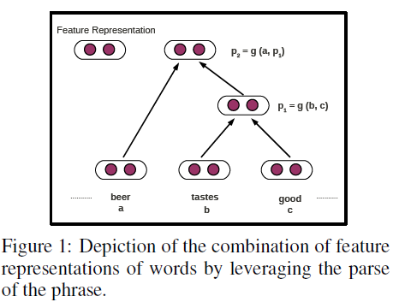

3.1.1 Recursive Neural Network (RNN)

Recursive neural network model uses the following equations to compute the parent vectors : 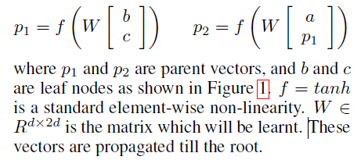

3.1.2 Matrix-Vector RNN (MV-RNN)

3.1.3 Recursive Neural Tensor Network (RNTN)

3.2 Objective Function

Our objective is to maximize the probability that the vector representation at the root of each parse tree is as close to the corresponding target distribution vector as possible. This can be achieved by using an objective function which minimizes the cross entropy error between these two vectors.

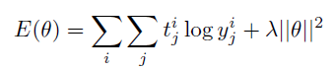

3.3 Formulations

**Separate Aspect Sentiment Model (SAS)**

In this formulation, we treat aspect extraction and sentiment extraction as two separate phases. We train two separate softmax classifiers, one each for aspect label and sentiment label respectively. In this process, an aspect label and a sentiment label are obtained separately and the (aspect, sentiment) pairs result from the concatenation of the two separate labels. Though this formulation is straightforward and easy to train, it has two major drawbacks. Firstly, as discussed in the introduction, the concept of joint modeling is not facilitated by this formulation. Secondly, this formulation cannot handle the snippets with multiple (aspect, sentiment) pairs because, though it is possible to obtain a chunk of aspect labels and another chunk of sentiment labels (from two separate classifiers), there is no way to associate them appropriately due to the separate training of the two softmax classifiers.

**Joint Multi-Aspect Sentiment Model (JMAS)**

In order to address the shortcomings of SAS, we propose a formulation that trains a single softmax classifier on the aspect-sentiment pairs. The class labels are now aspect-sentiment pairs. For example, (Taste, Positive) corresponds to one class label. This formulation now enables the joint capture of aspects and sentiments elegantly without making any explicit assumptions about their interactions. Further, this model can handle the snippets with multiple (aspect, sentiment) pairs. This can be achieved by allowing more than one element of the target distribution vector ti (defined in section Objective Function) to be set to the value 1. This set up poses the problem of aspect and sentiment detection as a multi-class softmax classification problem in the context of deep learning.

3.4 Training

4 Experimental Evaluation

Initialization and Pretraining

Dataset Description。

Baselines。

4.1 Quantitative Analysis

4.1.1 Single Aspect - Sentiment Pair Detection

4.1.2 Multiple Aspect - Sentiment Pairs Detection

4.1.3 Domain adaptation using word vectors

4.2 Qualitative Analysis

5 Conclusion

In this work, we attempted to bridge the gap between the literature on semantic compositionality and aspect-specific sentiment analysis. The framework we proposed encapsulates several important modeling decisions, such as joint modeling of aspects and sentiments, the ability to handle the presence of multiple aspects and associated sentiments in a given piece of text, and not making strict modeling assumptions about interleaving aspect and sentiment extraction. The evaluation that we carried out on real-world data demonstrated that our approaches incorporating sophisticated neural semantic composition functions consistently outperform other state-of-the-art techniques, with subsequent qualitative analysis confirming the need for various model elements.